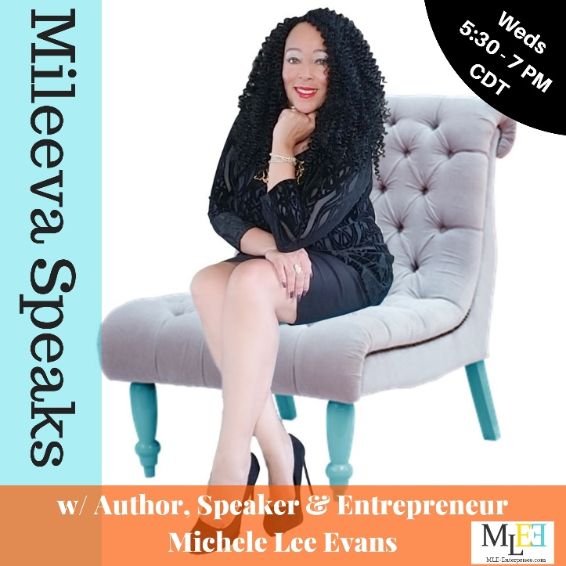
Mileeva speaks is a podcast show with a platform of music, networking and talk. I discuss current events, important issues that affect the African American Community, politics, relationships, parenting and other issues we care about. I also use my platform to help other entrepreneurs improve visibility for their products and services, while playing a mix of new and old school hip hop, soul and R & B. Mileeva Speaks has curated in just two months, 1000+ LIVE listeners and over 600+ replays per show and GROWING! To advertise during my weekly broadcast, please view the information below.

Current Advertising Packages:
*SILVER Package: $35 per month
Includes one 15 second business mention by Michele Lee Evans during the Mileeva Speaks weekly broadcast (4 to 5 times per month). Mention can include social media information.
*GOLD Package: $65 per month
Includes one 30 second audio commercial to be aired once during the Mileeva Speaks weekly broadcast (4 to 5 times per month). Must be exactly at or under 30 seconds and in WAV or MP3 format.
*PLATINUM Package: $95 per month
Includes one 45 second audio commercial to be aired once during the Mileeva Speaks weekly broadcast (4 to five times per month). Must be exactly at or under 45 seconds and in WAV or MP3 format. Includes business logo and link on the M.L.E Enterprises website.
*DIAMOND Package: $150 per month
Includes one 60 second audio commercial to be aired twice during the Mileeva Speaks weekly broadcast (6 to 10 times per month). Must be exactly at or under 60 seconds and in WAV or MP3 format. Includes Sponsor banner, business logo and links on the M.L.E. Enterprises website.
Please select the desired package and email info@mle-enterprises.com to receive an invoice, contract and autopay info.
Need help creating your commercial? For an additional but reasonable fee, the M.L.E Enterprises team can create the perfect commercial for you. Gather the important information you want listeners know, create your rough draft script and leave the rest to us.

